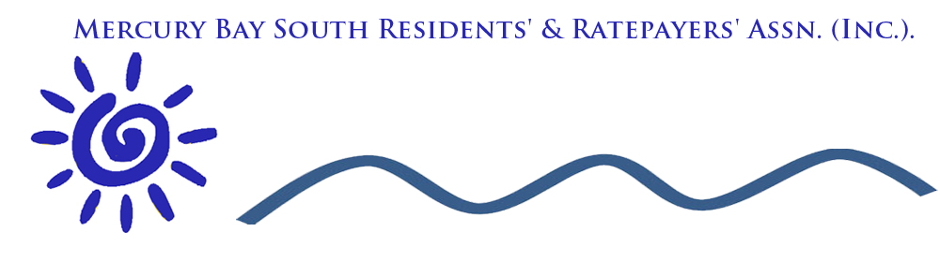

MBSRRA Committee Meeting

Agenda

Welcome

Apologies: Graham Morcom

Correspondence

Inward
Bob Nicholls
11/10/2018 Bob suggested a subcommittee be organized to support a Contender for the Local body elections
12/10/2018 Regarding Pontoon Letter discussing that the Residents and Ratepayers support the following conditions
- The present Fee Structure
- Implement boating trailer permit requirements
16/10/2018 Bill Stead communicated a mtg. on 17/10/2018 about Walkway proposal to Hahei from Whitianga Proposal around Walkway
Discussion revolved around getting Council representation as well as Community Boards. Bill Stead is interested in becoming more involved in Local Council Politics
16/10/2018 Alan Tiplady to meet on Wednesday 24 th OCT at 9
24/10/2018 Meeting Kane Jones regarding a reply to letter from TCDC dated 12/10/2018
25/10/2018 Email from Heather Bruce regarding Disability Parking at Ferry Landing and Cooks Beach CBD
28/10/2018 Paul Hopkins sent Email to Community Board re Historical and Signage to celebrate Cooks Beach
9/11/2018 Received email from John List regarding alternative ideas to Erosion at Flaxmill Bay
14/11/2018 Received email from Donna Blick regarding meeting Council staff attending will be:
Jan van der Vliet - Coastal Engineer
Allan Tiplady - District Manager North
Heather Bruce - Community Manager
Sue Costello - Community Facilities Field Rep
Friday November 30th at 10.am.
27/11/2018 Letter from Allan Tiplady regarding Pontoon Charges
Good afternoon Cyndy,
The letter from you and Kane Jones to Nicole Miell dated 27th October regarding the Purangi boat ramp has been referred to me to respond.
Your comments are noted and have been circulated to Community Board members again.
The fees and charges are revised on an annual basis in preparation for each years annual plan. I will ensure your comments are included in that process.
In the meantime the charges set by Council for the current year must continue to be applied. The suggestion that there be no charge to ratepayers but that visitors pay is noted and will be raised for discussion as part of the review.

Kind regards,

Allan.

Allan Tiplady;
District Manager, North.

28/11/2018 Reserve Management Plan review process Bob is willing to attend.

Outward
11/10/2018 Email to Heather Bruce for a meeting or letter regarding the pontoon and Solar lamp.
11/10/2018 Bob to find local fire chief’s details and Cyndy to contact Bill Stead for Hahei’s fire chief details
11/10/2018 email to Bill Stead regarding Fire Barometer
12/10/2018 Meeting with Hahei and Hotbeach
15/10/2018 email to Alan Tiplady requesting a time to talk about issues relating to Mercury Bay South/ Hahei and Hotwaterbeach
16/10/2018 Email to Committee relating to representative on Local Body
16/10/2-018 Email to members regarding Dave Fowells request that residents meet with Council on the 19th October at 12:30
22 /10/2018 Email all members the minutes of the meeting at Flaxmill bay .
22/10/2018 Email Committee minutes of Mtg with Alan Tiplady and Heather Bruce
27/10/2018 Letter to Nicole Miel from Kane and Cyndy regarding Pontoon Charges
8/11/2018 Email to Committee regarding Cairn Placement at Cooks Beach
11/11/2018 Forwarded John List’s email to Committee, Heather, Allan and Dave.
15/11/2018 Sent Agenda to Committee for meeting on the 29th

Matters Arising from Minutes

Meeting Minutes
4th October 2018
Venue: Cooks Beach Resort
Members were welcomed by Chairman, Graeme

Present
Barney Bowen, Bruce Philpott, Bob Nicholls, Cyndy Lomas, Graeme Lomas, Kane Jones, Fletch Handscomb, Paulette Tainsh, Paul Hopkins, Mel Bowen

Apologies
Graham Morcom
A warm Welcome to John Steele (Guest Speaker) and to new members Paulette, Fletch, and Kane.
John Steele Tuia 250
John is a resident of Cooks Beach as well as being a member of Captain Cook Society and has been attending the local MB250 trust meetings as a Trust advisor.

Structure of Tuia 250.
The national event is a ‘Tier 1” event – ie with highest level of government support, including PM, several ministries and senior staff.
The co-chairs of the National organising committee are National Jenny Shipley and Hoturoa Barclay-Kerr. Four separate landing site trusts (Gisborne, Mercury Bay, Bay of Islands and Marlborough Sounds) are co-ordinatin g activities in their areas.
The 2 major national events are (i) the opening ceremony in Gisborne and (ii) a powhiri at Wharekaho,Mercury Bay in October, both events expected to attract international media and interest.
A highlight of the local commemorations will be a five-day voyaging fleet visit - from Wednesday 16 October 2019 to Sunday 20 October 2019 - that will include waka, waka hourua (large double-hulled pacific voyaging canoes) and vessels from the Royal New Zealand Navy. There is a possibility that the fleet will also include the replica of HM Bark Endeavour, Cook’s ship.
Community individuals and groups are encouraged to become involved in the celebrations through the Mercury Bay co-ordinator Jan Wright. Applications for funding assistance can be made through a Lotteries Board fund – refer www. communitymatters.govt.nz/lottery-tuia-encounters/
The MB250 trust is hoping to ensure that the Endeavour can anchor off Cook’s beach for at least 48 hours on arrival before possibly moving to the Whitianga Wharf if possible. Some of the local activities may include
- Cross Country race from Whitianga to Thames. Funds raised go towards an outdoor leisure pursuits centre.
- Travelling Art exhibition by Swedish Gov.
- Kapa Haka festival
- Waka ama races
- Art Display at Whitianga town hall.
- Murals on town buildings by well known artists
- Sculptures
- Cook’s Beach Cairn Transit of Mercury cairn with a bronze sextant sculpture. (Bill Hayes has been commissioned to sculpt the sextant)
- A trio of local writers and historians are John Steele is writing a book - ‘Stories of Mercury Bay’ covering the 12 days of the Cook visit, to be used by schools, tourist groups, local tourist boat operators etc.
- Themed Scallop Festival
- A new Endeavour Buoy to show where Cook moored the ship on his 12 day stay.
- Pou by wharf Whitianga and also on a high visibility site in Whitby, UK.
- A legacy, historical trail with heritage signage explaining specific hisgtorical events which occurred at Cook’s Beach. Eg. where Cook handed over the first potatoes, filled his water barrels, raised a flag.
- Information on the Purangi bird, fish and plant life.
- Giant Pohutukawa which Cook passed by.
- Art exhibition in Cooks Beach Town Hall ( could include local schools)
- Development of Stella Evered Memorial park as part of proposed heritage trail and Coromandel walkway.
We have a limited time window to put in place events that are fun and goes towards the community leaving a legacy.
How best to keep up with national and local Tuia 250 events?
- Website www.mch.govt.nz/tuia-encounters-250
- Facebook keep up via TCDC Tuia 250 page
- TCDC Website www.tcdc.govt.nz – links to Mercury Bay 250
- Radio
- Contact Jan Wright mercurybay250@gmail.com

A warm welcome to our new Committee Members.
Fletch Handscomb, Kane Jones and Paulette Tainsh to our committee.
1) Barney, 2) Graeme

Financial Report
Presented by Barney
Balance Statement: 4 Oct 2018 $4891.07
Lodgements since then $30
Total Bank Balance $4921.07

Term Deposit $6245.75
- Barney 2) Cyndy

Erosion
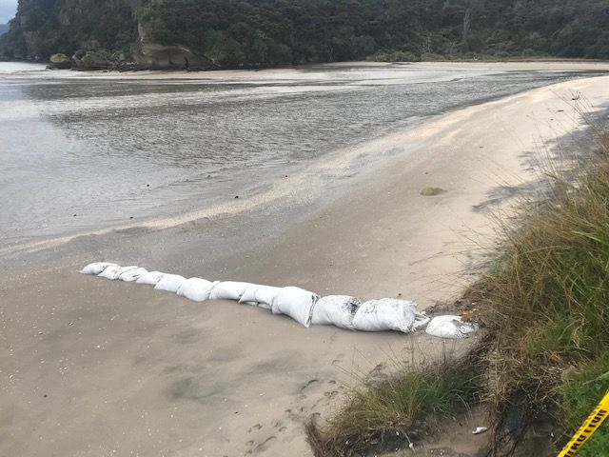
Members discussed the issues at both Flaxmill Bay and Cooks Beach in some depth, and several viewpoints were expressed. There was some concern that the trial groyne placed at Flaxmill Bay has initiated a somewhat negative response from TCDC, despite appearing to have many merits.
The problems at Cooks Beach have made it extremely difficult to re- instate the memorial which had been washed into the sea. With time ticking, it is imperative that work start on erosion control a.s.a.p.
The Chairman and Secretary write to TCDC and seek definitive up-dates as to plans for both areas, indicating the urgency for work to be completed around the memorial site.
1)Barney 2) Paulette

Flaxmill Bay Footpath

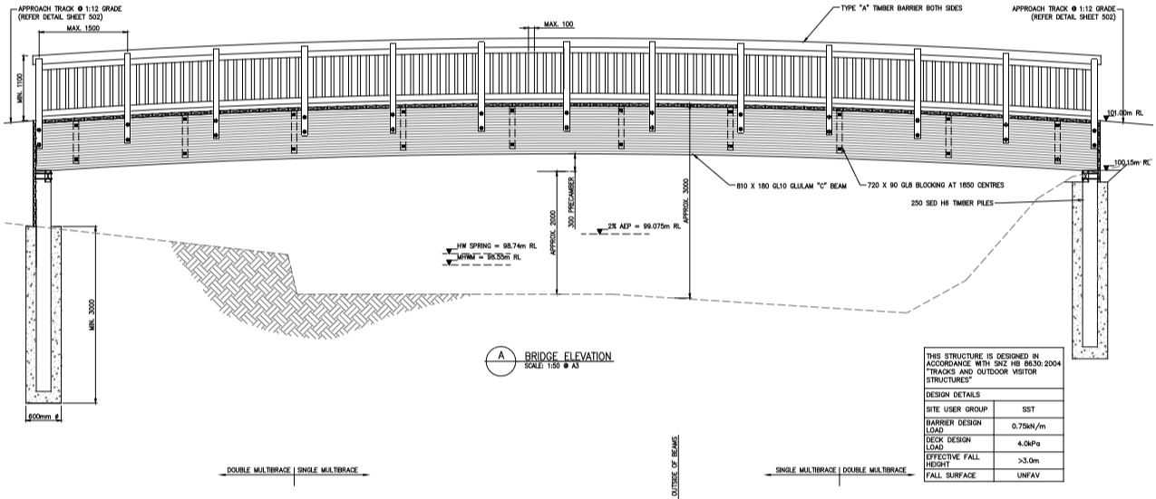

After a period of consultation, Andrew Scobie has informed us that the designs have been finalised, and that TCDC are in the process of applying for a consent.
We are delighted that our project is now close to fruition and thanks Andrew and others for their efforts.
A copy of the plan will be distributed to all committee members and then placed on the MBSRRA website

Fire Barometer
The planned fire barometer for the area between Dalmeny Corner and Dalmeny Bridge is still ongoing.
Secretary Cyndy and Bob Nicholl will liaise to endeavour to get input and consent from the Chief Fire Officers at both Cooks Beach and Hahei

Timed Parking at Ferry Landing
The proposal has been abandoned by TCDC and thus the Status Quo will remain. Cyndy to keep in contact with Sue Costello regarding two disabled carparks at Ferry Landing and Cooks Beach CBD.

Boat Ramp and Pontoon
Results of the recent survey were outlined by Cyndy stating that the majority of respondents were in favour of retaining the pontoon, but that the fee structure is too high considering the influence of the tides on exit and entry into the estuary. It was noted that perhaps one of the fee options on the survey should have been a no charge.
We now await the following.
- A response from the Council re- fees
- The installation of a Solar light as promised
- Sealing of the access road and car park. (Part of the 10 year plan)
Kane and Cyndy to write a letter to Council

Cooks Beach Scenic Pathway
Our committee agreed to support the Parks and Reserves Committee to create an access way to the beach between Richardsons and the Vessel. Stage 1 will be the building of the Hoggin Path while Stage 2 will involve landscaping the whole area.

Local Body Elections
Mercury Bay South area needs a contender to represent us. Due to changing demographics Ferry Landing, Flaxmill Bay and Cooks Beach might need its own ward. We already have support from Hahei and Hot Water Beach

Community Emergency Response
Bob to represent us on the 17th November

Communicating with the Community
There were discussions on the best ways to communicate with our community. The following were suggested
- Informer
- Hauraki Herald
- Facebook
- Newsletters
- Website

Pathway to the Hall past Mussel Bed Accommodation
Great to see this finished. A big thanks to all who contributed. A letter of Thanks has been sent to TCDC by the secretary.

Who does What
Graeme / Cyndy/ | Write letter To TCDC regarding Erosion
Bob and Cyndy | Fire Barometer
Cyndy / Kane | Pontoon
Bob | Represent us at Emergency Response Meeting
Cyndy | Disabled Parking Reminders to TCDC

Meeting Closed:3:30

Next Meeting: 29th November

Annual General Meeting : Sunday of Anniversary Weekend.

Financial Report
Bank Balance 1 December 2017 3696.69
Income
Subscriptions 1360.00
Donations 60.00
Total Income 1420.00
Less Expenditure (125.62)
Bank Balance 29 November 2018 4991.07

General Business
- Erosion Issues

- Captain Cook Cairn

- Freedom Camping/ Tourism

- AGM.

- TCDC Elections 2019

- Kerbside Collection

