Mercury Bay South Residents and Ratepayers Association
Meeting Minutes
Time / Date: | 4:00 pm Saturday, 5th February, 2022 | Venue: | The Vessel
Attendees: | Committee  Dave Baardman, Steve Lloyd, Bruce Philpott, Tom Riddle, Chris Harris, Paulette Tainsh, Cyndy Lomas  Guests  Alison Henry, David Ninke
Apologies: | Paul Hopkins, Kane Kat, Dal Minogue
Keen Supporters
ITEM | DISCUSSION |  |  | ACTION | WHO
Warm Welcome  Financial Report  Subs Online  Tina Bartlett  Contributions the MBSRRA could gift to the Hall Committee. | It was great to see nearly everyone there and Covid that thwarted our progress seemed nonexistent.  Minutes from last mtg.  Subs $155  .30  $ 95  $250.30  Closing Balance $8621.24  $95.00  $8717.16  Paulette has submitted the Accounts to Corporate Society. The Financial Report was audited by John Hamilton. Proposed to give a bottle of wine regarding the effort and time he donates.  Paulette is working on Subs online which will electronically send out invoices and receipts.  General Business  Items to be donated to the Hall  Item Cost  Lectern With Shelf underneath. Donated and made by Tom Harsant  Datashow Chris Harris to investigate Retail Prices |  |  | Paulette Tainsh moved they be accepted, Seconded Bruce Philphott  Moved Cyndy Lomas  Seconded Bruce Philphott  Subs online  Contact Sam Harsant  To investigate Prices within the Confines of a $2000 budget | Paulette Tainsh  Cyndy Lomas  Chris Harris
Security Camera  Loading Zone outside Liquor Store  Flaxmill Bay  Disabled Access to the Beach  Pontoon  Future Planning for Commercial Development  Upkeep and Maintenance  Pine Trees  Road Safety  Election of Offices | Braeden Jack has knowledge and experience dealing with this issue. Details to be sent to Kane West  To be designated for Disabled Parking.  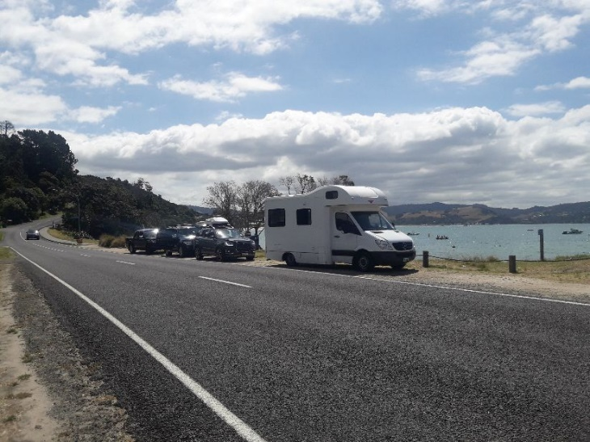  - Bollards need to be erected to stop people parking on the Footpath.  It has become a Safety issue.  - Picnic Table  Would like a Picnic Table to be restored as the original was removed due to erosion.  - Clear Access Points  - Need Signage for times Dogs are to access the Beach ( Eggcentic End ). Contact DOC.  - A big storm has undercut the path and the stream has eroded. Possible solution to this is dredging a channel to reroute the stream.  - Contact Jamie with regards to an additional groyne situated by the toilets and little stream.  This regards access to the beach for disabled people. A ramp to allow this needs to be submitted to the 5 Year Plan. The committee are in support of this endeavour suggested by Alison Henry.  Damage has been sustained by the Tongan tidal wave. There is no soft edge on the Pontoon to buffer the impact on boats. For Progress update regarding these issues contact the Council.  As Cooks Beach is experiencing expediential growth there may be a need for industrial and Commercial activity to be planned in the area. Discussion followed. This could be put in a 5 Year Plan  It has been noted that some areas within the confines of Cooks Beach need mowing and a general tidy up  The felling of Pine Trees at the Purangi . This issue was bought up at the AGM. Unfortunately, these have been deemed as Health issues and would be gradually replaced with natives.  Update from Ed Varley  Interim Chairman – Paul Hopkins  Vice Chairman – Chris Harris  Secretary – Cyndy Lomas  Treasurer – Paulette Tainsh  Steve Lloyd  Dal Minogue  David Baardman  Bruce Philphott  Tom Riddle  Kane Jones  Meeting Closed at 6pm.  L |  |  | To be sent to Kane Jones  Cyndy Lomas to contact Sue Costello  Cyndy Lomas contact Sue Costello  Discuss with Sue Costello regarding contacts for DOC  To Contact WRC to dig out the Stream  Jamie Boyle  Submission to 5 Year LTP. For more details regarding costing etc liase with Alison Henry  Liase with Heather Bruce.  contact Sue Costello  To investigate to the latest developments | Cyndy Lomas  Cyndy Lomas  Bruce Philphott  Sue Costello  Paulette Tainsh  Cyndy Lomas  Alison Henry  Bruce Philphott  Chairman  Cyndy Lomas  CC Paulette  Paulette Tainsh  Cyndy Lomas

