Mercury Bay South Residents and Ratepayers Association
Meeting Minutes
Time / Date: | 4:00 pm Sunday, 17th April, 2022 | Venue: | Harcourts Real Estate, Cooks Beach
Attendees: | Committee  Dave Baardman, Steve Lloyd, Bruce Philpott, , Chris Harris, Paulette Tainsh, Cyndy Lomas, Paul Hopkins,  Guests  Alison Henry, David Ninke, Pamela Frost, Tony Frost, Alison Henry, Bob Nicholls, Neil McMurdo, Sue Mcmurdo, David Ninkie
Apologies: | Dal Minogue Tom Riddle
Keen Supporters | Thanks to Paulette and Hendry Tainsh for being so accommodating and providing a permanent space to meet and provide photocopying. The Association thanks you:  Harcourts Cooks Beach
ITEM | DISCUSSION |  |  | ACTION | WHO
Warm Welcome  Financial Report  Subs Online  Tina Bartlett  Contributions the MBSRRA could gift to the Hall Committee. | The committee sends a warm welcome to our Guests who showed a keen interest in proceedings. Thankyou  Minutes from last mtg.  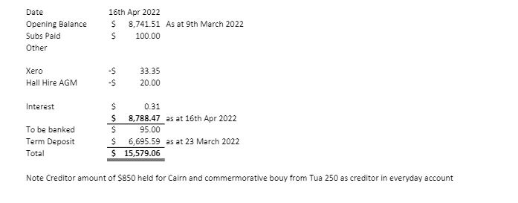  Paulette is in the process of getting this developed.  Matters arising from the Minutes  Items to be donated to the Hall  Item Cost  Lectern With Shelf underneath. Donated and made by Tom Harsant. Cyndy has contacted Sam and notified the intention to Tina Bartlett  Datashow Waiting on approval from Fletch Handscomb. We will get a variety of quotes to allow for the best option. |  |  | Chris Harris moved they be accepted, Seconded Bruce Philpott  Moved Cyndy Lomas  Seconded Bruce Philpott  Subs online  Tom Harsant and Tina Bartlett have been contacted  To investigate Prices within the Confines of a $2000 budget | Paulette Tainsh  Cyndy Lomas  Fletch Handscomb providing Specis to suit the confines of the Hall
Flaxmill Bay  Stairs at Flaxmill to access the Beach  No Parking Lines on the entry to Homestead Lane.  Road Calming measures on entry to Flaxmill Bay parallel with the Camping grounds  Dune Planting and reshaping of entry to Flaxmill Beach  Erosion at Flaxmill  Disabled Access to the Beach  Signage at the Beach  Information Sheet  Road Safety  Tennis Courts  Parking Area opposite the Commercial Area  Purangi upgrade  Freedom Camping  Walkway Lighting  Planting behind the Fire Station needs maintenance  Lakes and Exotic plant life and Animals  Increase in Rates  Next Meeting | 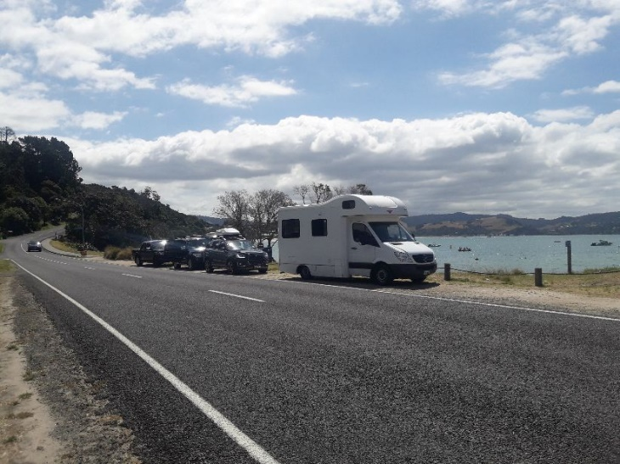  - Bollards will be stop people parking on the Footpath.  It has become a Safety issue.  - Contact has been made to Jamie regarding an additional groyne situated by the toilets and little stream. This has to be considered after a 5 year trial of existing groynes. There is a possibility that the most eastern groyne will be removed as it has achieved its purpose.  Access to Flaxmill Beach has become difficult. A suggestion was made that set of stairs, like the ones at Hahei be purpose built to gain entry to the foreshore.  This was discussed and is proposed that this will be brought to the attention of ED Varley  Report back from Bruce Philpott  Jamie Boyle is investigating Erosion and Sue Costello is managing the creation of a new channel as it is undermining the path. Realignment of the stream is a cheaper option rather than configuring the pathway  This measure is no longer feasible along the entry points of Cooks Beach. Paul Hopkins will pursue this as a possibility as part of the Purangi upgrade.  Different messages are being communicated by TCDC and DOC.  There is a need for a coordinated message for everyone as it gives clearer guidelines for dog owners on usage of the beach  An information Sheet is being collated by Alan Henry concerning groups associated with Mercury Bay South. Harcourts generously will sponsor the cost of $90  It was noted that a SUP would possibly be a costly effort, but it must be noted that a walkway / cycle way has been built from Longreach to the village and connects from the Hall to Flaxmill. Most cyclists use this now. Post Meeting: Cyndy has contacted George Mathew regarding funding. Also, the Roading Strategy can be found at this link regarding two scenarios https://mercurybaysouthratepayers.weebly.com/road-safety.html  A submission has been made to Council regarding the history and proposal that the Council takes it over. It must be noted that the Tennis Club has money to spend on refurbishing the Courts if needed.  https://mercurybaysouthratepayers.weebly.com/tennis-courts.html  Permanent strip to allow for parking and No Stopping lines on Captain Cooks Rd from Build link to create more visibility for turning traffic.  https://mercurybaysouthratepayers.weebly.com/purangi-reserve-upgrade.html In addition to upgrade the Community discussed if this could be deemed a 30K speed zone due to the high usage by Holiday Makers, Boaties and Freedom Campers  Freedom Camping Bylaw has expired, and it is up to us to finalize where to accommodate them  Liz de Vere has brought it to our attention that lighting is needed for the Walkway from the Fire Station to the Village  .  This area needs to be maintained regularly  There is a big stagnation problem at the Lakes due to the encroachment of weeds. A letter will be sent to Greg Roache regarding frequent eradication program. Also, there was noted that the population of Turtles has increased. Post meeting: This has been completed by David  This was discussed, with Paulette investigating if rates were related to the Current valuation and improvements. Cyndy Lomas to notify Ratepayers of the timetable to make submissions to Council in the next newsletter.  Queens Birthday Weekend Sunday 5th June at Harcourts Cooks Beach 4 pm |  |  | Bruce Philpott to liaise with Jamie Boyle. Complete with a community drop-off. Presently Jamie is consulting with Iwi.  Parallel Parking for vehicles accessing the Beach with the inclusion of a Disabled Parking.  Bruce Philpott will be overseeing this issue by keeping in regular contact with Jamie Boyle  Bruce Philpott to contact Jamie Boyle, Sue Costello  Cyndy Lomas to bring this to the attention of Ed Varley  Jamie Boyle  Bruce Philpott to report back and oversee Community Involvement  Alison Henry has communicated with Council regarding this.  Alison Henry reported back, Paul Hopkins to pursue the idea as part of the Purangi Upgrade  Alison Henry  Sponsorship by Harcourts Cooks Beach  Cyndy Lomas to liaise with Ed Varley and George Mathews  Paul Hopkins to oversee this project  Paul Hopkins to oversee this project in communication with Heather Bruce  And Community Board  Overseen by Paul Hopkins and reference to Sue Costello and Ed Varley  Paulette Tainsh  Heather Bruce will discuss this to bring some closure  Cyndy Lomas to contact Fire Brigade  Paul Hopkins to contact Sue Costello  Dave Baardman will send a letter to Greg Roache regarding this matter | Bruce Philpott  Jamie Boyle  Bruce Philpott,  Jamie Boyle  Bruce Philpott  Cyndy Lomas  Ed Varley  Cyndy Lomas  Ed Varley  Bruce Philpott  Jamie Boyle  Sue Costello  Jamie Boyle  Alison Henry  Paul Hopkins  Sue Costello  Jamie Boyle  TCDC: Heather Bruce  DOC  Alison Henry  Paulette Tainsh  Cyndy Lomas  George Mathew  Ed Varley  Paul Hopkins  Paul Hopkins  Heather Bruce  Jeremy Lomas  Paul Hopkins  Sue Costello  Ed Varley  Paulette Tainsh  Heather  Bruce  Cyndy Lomas  Fire Chief  Sue Costello  Paul Hopkins  Greg Roache  David Baardman  Paulette Tainsh  Cyndy Lomas

