A warm welcome was extended to everyone including guest, Del Minogue.
Apologies : Barney, Bob, Graham

Matters arising from Minutes
There have been many meetings with Council regarding several Issues.

Green Waste
Green Waste Transfer Station is on the Year 10 plan. Still awaiting action. Alan Tiplady informed.

Disabled Parking at the CBD and Ferry Landing
Heather Bruce has forwarded this initiative to allocate 2 disabled Parking spaces at each area to the Transport Division.

Pontoon
Cyndy and Kane wrote a letter regarding excessive fees charged at the Pontoon. Our comments were noted by Council and as the fees are revised on an annual basis our concerns will be raised the next meeting reviewing the charges.

Tuia 250
Graeme is meeting with Council and John Steele with regards to this. One must note that Cooks Beach is an important part of Cooks journeys and so should be recognized as a place of importance.
The Cairn will be outfitted with a sextant on the top to commemorate Captain Cook and the Maori people who lived here.
There is a lot of interest shown in forming a group to liaise with Jan Wright to investigate what is happening and provide help we can give regarding the Festivities. Joe Davis, Ngati Hei, is on the committee (Tuia 250) and is also a good starting point to find out what progress is being made. Fletch offered to organize this. A message needs to be sent to Stephan thanking him for the Sand Competition needs to be sent.
1) Fletcher
2) Kane

Communication with Council
A combined meeting including Mercury Bay South, Hahei, Hotwater Beach and Council is proposed to take place three times a year. It was discussed that we need to create a list of people who are responsible for portfolios to communicate directly to the person concerned. Paulette will collate a list.

Outward / Inward Correspondence

Inward
11/10/2018 Bob suggested a subcommittee be organized to support a Contender for the Local body elections
12/10/2018 Regarding Pontoon Letter discussing that the Residents and Ratepayers support the following conditions
- The present Fee Structure
- Implement boating trailer permit requirements
16/10/2018 Bill Stead communicated a mtg. on 17/10/2018 about Walkway proposal to Hahei from Whitianga Proposal around Walkway
Discussion revolved around getting Council representation as well as Community Boards. Bill Stead is interested in becoming more involved in Local Council Politics
16/10/2018 Alan Tiplady to meet on Wednesday 24 th OCT at 9.00 am
24/10/2018 Meeting Kane Jones regarding a reply to letter from TCDC dated 12/10/2018
25/10/2018 Email from Heather Bruce regarding Disability Parking at Ferry Landing and Cooks Beach CBD
28/10/2018 Paul Hopkins sent Email to Community Board re Historical and Signage to celebrate Cooks Beach
9/11/2018 Received email from John List regarding alternative ideas to Erosion at Flaxmill Bay
14/11/2018 Received email from Donna Blick regarding meeting Council staff attending will be:
Jan van der Vliet - Coastal Engineer
Allan Tiplady - District Manager North
Heather Bruce - Community Manager
Sue Costello - Community Facilities Field Rep
Friday November 30th at 10.am.
28/11/2018 Reserve Management Plan review process Bob is willing to attend.

Outward
11/10/2018 Email to Heather Bruce for a meeting or letter regarding the pontoon and Solar lamp.
11/10/2018 Bob to find local fire chief’s details and Cyndy to contact Bill Stead for Hahei’s fire chief details
11/10/2018 email to Bill Stead regarding Fire Barometer
12/10/2018 Meeting with Hahei and Hotwaterbeach
15/10/2018 email to Alan Tiplady requesting a time to talk about issues relating to Mercury Bay South/ Hahei and Hotwaterbeach
16/10/2018 Email to Committee relating to representative on Local Body
16/10/2-018 Email to members regarding Dave Fowell’s request that residents meet with Council on the 19th October at 12:30
22 /10/2018 Email all members the minutes of the meeting at Flaxmill bay .
22/10/2018 Email Committee minutes of Mtg with Alan Tiplady and Heather Bruce
8/11/2018 Email to Committee regarding Cairn Placement at Cooks Beach
11/11/2018 Forwarded John List’s email to Committee, Heather, Allan and Dave.
15/11/2018 Sent Agenda to Committee for meeting on the 29th
that Inward and Outward be accepted
1.Paulette
2.Fletch

Financial Report
Bank Balance 1 December 2017 3696.69
Income
Subscriptions 1360.00
Donations 60.00
Total Income 1420.00
Less Expenditure (125.62)
Bank Balance 29 November 2018 4991.07

1) Kane
2) Fletch

A discussion followed that the monies should be spent on causes and projects that are transparent to the residents.
Donations should be targeted to a Community Cause. It was decided to discuss this at the AGM.

General Business

Signage
There is a need for signage about noted areas and facilities. We need to decide as a Ratepayer Group to decide what signs will be about and placement.
Signs could communicate
- Historical Points of interest
- Accommodation
- Food
Placement would be on the Turn off at Hot Water Beach Rd. It was noted that signs would have to be a certain dimension and a discussion needed to be held with Council regarding this. Ratepayers organization could contribute to funding.
Fletch / Paul would create Significant areas on Google Maps. This can be completed by January.
Paul and Fletch will approach Council the Council regarding signage and will keep us informed of their progress.

Erosion
Graeme is meeting with the Council on the 30th November and will talk to Jan about it.

Flaxmill Bay Bridge
This has been put to tender and things are in motion.

Relocation of Rubbish Bin at Ferry Landing
It was raised there was a need to relocate the Rubbish Bin at Ferry Landing due to the fact it was hidden by vegetation and cannot be easily found. Rubbish was being deposited in the Shed.
Paul offered to deal with this.

Freedom Camping
This has got out of control. There were 27 vehicles camped at the Purangi while it can accommodate only 5 and some were not self-contained. There is little consistency over the whole country It needs to be policed at night and a large infringement notice need to be issued for those who are not adhering to the laws. The by law needs to be reviewed as it is outdated and is not accommodating the need. Paulette will write a draft resolution for the AGM, as what is happening now is unsustainable.

AGM
We need to invite Speakers representing the Council and speaking to the issues.

Hahei Ambulance
Graeme represented us at the opening of the Hahei / Mercury Bay South / Hotwater Beach ambulance opening.

TCDC Elections
We are looking for representation on the Community Elections. All ratepayers can vote but non-residential property owners can allocate only one person to vote. For more information can be found here.

Kerbside Collection
On Tuesday the 20th we awoke to find that the Council was not going to collect from Cages. This caused a big Community upheaval. Health and Safety laws are being violated It is fine for permanent residents but for outer townies this creates a dilemma. We need a unified voice with Hot water Beach and Hahei to firstly look at the conditions through the Information Act of the contract with Smart Environment . Graeme to write a letter on behalf of the Mercury Bay.
Could be an item for the AGM.

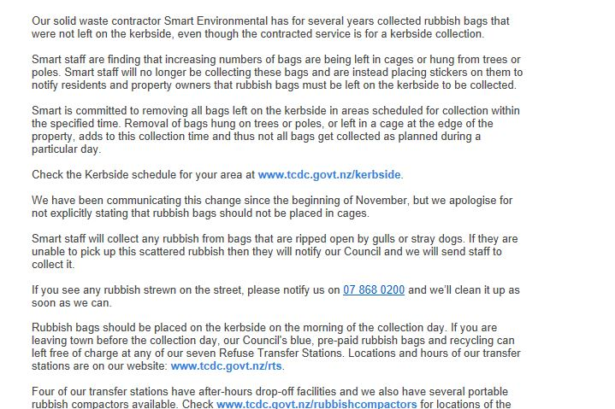

Next Meeting
AGM
27th Sunday Anniversary Weekend at 4 pm. Cooks Beach Hall
Possible Topics to be raised?
- How we spend our Money raised and concentrating on donations rather than subscriptions
- Freedom Camping
- Kerbside Collection
- Overview of council expenditure and activities
Possible Guests?
- Mayor, Sandra Goudie
- Allan Tiplady
- Councillors
- Community Board

Who does What?

Organize a meeting and liaise with John Steele  on what is happening with Tuia 250 | Graeme, Paulette and Fletch
Create a list of people in TCDC , about their responsibilities and contact details | Paulette
Signage indicating noted areas and facilities around Mercury Bay South | Fletch and Paul
Relocation of Rubbish Bin at Ferry Landing | Paul
Draft Resolution on Environmental Assessment with regard to Freedom Campers | Paulette
Kerbside Campers and the use of Cages to Council | Graeme

