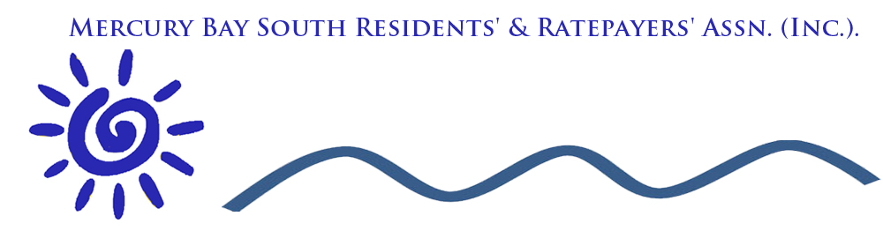

Minutes: taken from Public Meeting 5th April 2018 at Cooks Beach Community Hall.
Purpose: to discuss the 10 year plan and issues pertaining to Cooks Beach, Flaxmill Bay and Ferry Landing.
Present: Members of the Public ( approximately 70) , South Mercury Bay Residents and Ratepayers representatives, Scott (Planner TCDC) , Angela (Management TCDC), Alan (Area Manager for Mercury Bay including the Mercury Bay South), Heather (TCDC Whitianga office) representing the Council.
The meeting opened with a warm welcome to all and sincere thanks to Shenagh Gleeson, staff of Richardsons Real Estate and the Mercury Bay South residents and Ratepayers committee.
Scott presented the 10 year plan. He stated that there would be no decisions made but using the meeting as a vehicle for disseminating information.
70% of Council income is derived from rates. To shape the future of our district there are only a few days left for submissions to be in by 16th April at 12 p.m. Preference is given towards digital submissions. You can save, rework, exit and return to typed on-line submissions. The database holds all your submissions so comparisons can be made in subsequent years. There are over 500 projects with an income of 85 million a year. The plan wil be adopted by the 30th June 2018
Within the district there are over 27,500 rateable properties. (Mostly residents). 48% of residential units are unoccupied. Population is seasonal with a high visitor population in summer.
Rates
Current Rates have a 5.2% increase during the first year. 4.2% in second year and 3.1% in third year. 10 Year average of 2.8% Why the increase?
- 5% increase to go to the Power NZ Reserve Fund (this fund was created from the sale of the Power NZ shares. The proposal is to now accumulate the interest from this fund instead of using this interest for project expenditure. This will ensure benefit accrues for now and for future generations).
- Higher costs for our assets - depreciation, maintenance, damage, water quality, inflation and storm damage.
Every 3 years re-valuations affect properties. If the Property land value is increased by 35% you will take a bigger share. If less a decrease. Land values on average have increased by 40%
Some of the major proposals for the Long Term Plan are:
- A new Aquatic Facility is planned in Thames. The present site is an urupa and when the lease expires there is a need for a replacement facility. This is estimated as being $21m. Three options have been presented. Reference to Scott for more detail.
- Wentworth Valley Road to be sealed
- Up-grading council-owned roads not currently maintained
- Pottery Lane Coromandel Town Rd extension
- Totara Valley – service extensions
Proposals
- Remove the rate remissions for Second Dwellings
- Remove economic development rate from commercial and industrial properties and transfer to general ratepayer.
- It is proposed to increase the amount of rating from the UAGC (Uniform Annual General Charge) and reduce the amount collected from the land value base rating. The increase is limited to 30%.
Details Contact Scott.

Mercury Bay
The Hoggin Path Proposal at Cooks Beach is $350,000 (not $1.3 million as was in the original document). The Hoggin path envisaged would be the same as the Whitianga Walkway. Where the path is to go and whether or not this is a priority needs discussion.

Lees Rd, Hahei
Currently has $139,000 in the 2019/20 year for widening and sealing the road and planning a carpark. The forecast $3m plus figure is for the total cost. It was unclear if this is a public/private development and where the costs might lie.
If you want a breakdown contact Scott.

Question and Answer
Sustainability
Sustainability factor was discussed. The Question was did the Council have a strategic sustainability plan.
The Council has no strategic plan to include this in the 10 year plan but welcome submissions with regard to this.
Erosion Purangi Reserve
Sandbank for Captain Cook Memorial is a Health and Safety risk. It costs the Council approx $10,000 per pushup. This is the site of the Cook memorial and is of importance to NZ. The money spent on soft fixing (sand replacement) is a holding pattern and some people considered this to be a waste. There were suggestions made about groynes and a stone wall. There were diverse opinions about how to manage beach erosion. This must be a priority for Council.
Council has employed a coastal engineer and can now feel a lot more assured about progress.The coast is a challenging natural environment and even coastal scientists and engineers have differing opinions.
Dalmeny Bridge
This has been brought up for the last 25 years. It is the only entrance to and exit from Cooks Beach, Hahei and Hotwater Beach. It was suggested that the money spent on Lees Rd could be better utilised and redirected to the expense of a new bridge. If there is a storm the whole area is held to account as it is unpassable. The Dalmeny Bridge is a big issue and the three areas of Hot Water Beach, Hahei and Cooks Bridge are to make a combined submission to Council asking that this bridge is made a priority project. The more submissions made the more the council will take notice. If you can’t get access to the area through the bridge it makes the proposed sealing and carpark facilities in Lees Rd a total waste of ratepayers’ money.
Erosion at Flaxmill Bay
Sand pushups or “soft option” are a holding pattern but not a permanent fix. This area is a priority for attention and again submissions and proposals for this problem to be investigated and fixed need to be made.
Footbridge at Flaxmill Bay.
There is a need for a footbridge and pathway. The money allocated by council is targeted for the bridge and not the pathway. It was stated at the meeting that instead of funding the Hoggin Path, which is not needed, funds would be better spent on completing and maintaining the entire footpath along Purangi Road from Rees Ave to Ferry Landing including the footbridge at Flaxmill Bay.
Pathway to the Winery
Presently it is dangerous to walk to the Winery on the grass from Rees Rd. Could the Council consider a committed walkway
Lack of Communication.
Some people at the meeting were concerned about the lack of consultation and were frustrated that the needs of Cooks Beach were being ingnored. Scott reassured those present that there is not an us/ versus the community. The door is always open to find resolutions. Scott was asked to quantify what was the standard procedure for consultation. Scott replied that there was no one process but a spectrum of engagements and conservations through submissions both on-line and on paper.
Car Park / Ferry Landing
It is proposed that four-hour parking be introduced to the lower car park at Ferry Landing. This was proposed without any consultation with the community. Scott reassured the meeting that this would not go ahead without community discussion.
Green Waste Disposal
There used to be one but was abused by the Public. The old dog-dosing strip, which is land owned by council, could be used for a green waste disposal for our community. It was also noted that the council has been asked in the past to provide MB South residents with 6 passes to the Whitianga site to recompense and help with costs. This was never done.

Whitianga Boat Ramp Can this item be deletedThe comments below relate to the Waterways and not to the boatramp.
Whitianga canal reclamation could have affected the sediment dumped at Cooks Beach creating dumping of silt.
Purangi Upper Harbour Walkway
If you want a plan of the project please contact Scott.

The Chair closed the Meeting and thanked everyone for their attendance.
People to contact regarding this meeting
Scott: scott.summerfield@tcdc.govt.nz.
Graeme: gandclomas@xtra.co.nz

