 | 1st January 2023  Cooks Beach Hall  Guest Speakers  Honorable Len Salt  Jamie Boyle  Andrea Whitehead  Frank Geoghegan  Welcome address by Chairman.  Apologies Erica Husson  Summary of Len Salt’s Address  Summary of Len Salts address  Presentation by Coast care Waikato  Powerpoint Presentation by Greg Geoghegan | Mercury Bay South Residents and Ratepayers Association  AGM  - Email: gandclomas@xtra.co.nz  - Address: 945A Purangi Rd Cooks Beach  - Website: https://mercurybaysouthratepayers.weebly.com/
Len discussed the aftermath and recovery period od Cyclones Hale and Gabrielle. There was over 6m of rain that fell causing 200 slips on local roads ,34 red stickered homes, the cessation of the Ferry Service to Auckland and affected our Business Community. The Council secured an early government commitment of 8 million which injected 40thousand per business.
Council Emergency Management were heroes reacting to the aftermath with practiced skill to the evacuation of Homeowners and businesses.
The agenda now is:
- Roading resilience in the Long Term Plan
- Reprioritizing the Regional Land Transport Schedule
- Roading Repairs culminating into 811 million and employing local contractors with spinoffs to our local community.
- Security of access creating stability

Future Projects include:
- Cycling and walking amenities
- Coastal protection responsive to climate change
- Rating Review
- Create a Housing strategy.
- Spatial planning is returned.
- Rebuilding House capability
- Local decision making ensuring decisions are made for local people.

Waste and Recycling
Presently there is 30 ½ tonnes of waste to Paeroa annually. A review will be conducted to manage this more effectively.

3 Waters
The repeal of 3 waters by the government translates to Council maintaining and paying for water, this has resulted in what was thought to be a budget 13 million ballooning to a 19 million cost. This has meant a 1% increase added onto Rates.

Questions
- Why are Waste Management Services run by Australian Companies benefit Australia rather than local Businesses.
At the present time we try to keep firms as local as possible but where cost savings and efficiency outweigh what would be the cost to Ratepayers, we have to maintain the most expedient approach

- Who do we thank in Waka Kotahi regarding Highway 25
Email the Mayor and he will respond with the address of the person who oversees the operation.

- The Tapu Coroglen is in fantastic condition but trees are currently affecting visibility.
This will be communicated to roading services

- Along roadsides banks are being cleared and destroying the foundation of hillsides. To eliminate this roadsides and berms need to be replanted in natives.

- For the past 18 months the Ratepayers have notified the Council of the state our Lakes are in choking with weed. Council employees are doing work that is ineffective and wasting Council resources.

- The Mayor will investigate this concern and make it known to the parties involved.

- Storm water Can we have a plan regarding this?
The Council are committed to some form of stormwater mitigation and will report back on some hard answers.

- A few staff on Council that were encountered had difficulty communicating with mutual respect.
The staff have been driven by a tough year and are often caught in the middle when communicating.

- Te Mata Arowai was put in place to make sure there was consistent water standards across the country. How would you comply?
The water quality regulator the Thames Water Council will have 19 million spent to keep ensuring water standards are consistently up to standard.

- Is it the role of Council to provide services like housing that are outside core values instead of concentrating on necessary issues.
Council is playing a facilitation role without any cost to Ratepayers. There has been a focus on core services but has a role that whatever is built is in connection with amenities.

Presentation by Cost Care Waikato
Cooks Beach lost >11m of dune during Cyclone Hale and Gabrielle. This included all the sand binding plants needed for the natural self-repair process. Coast care and Thames-Coromandel District Council, with help from the community, propose to restore the dunes from central reserve to the east over a number of restoration seasons.

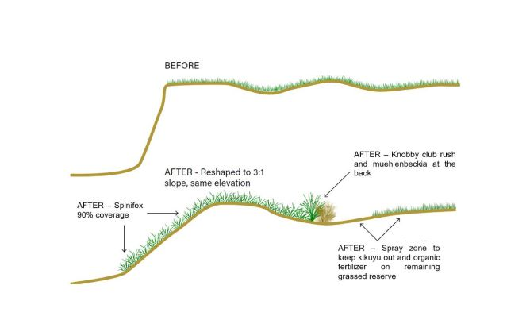

Why do we need native sand binding plants? Spinifex (Spinifex sericeus) and Pingao (Ficinia spiralis) are New Zealand's native sand-binding plants. Over millions of years, they have specially adapted to handle the New Zealand coastline's hot, dry, high salt conditions. They can grow runners out towards the ocean of up to 8m a season. These plants catch sand blowing along the beach, building dunes out towards the sea. This forms a sacrificial buffer of sand that builds over time to be eroded during a storm. Without these plants, dunes do
not self-repair when conditions are suitable.
These plants are hard to propagate and private nurseries at home cannot be utilized as the Council can only use credible sources ensuring healthy and disease free plants.

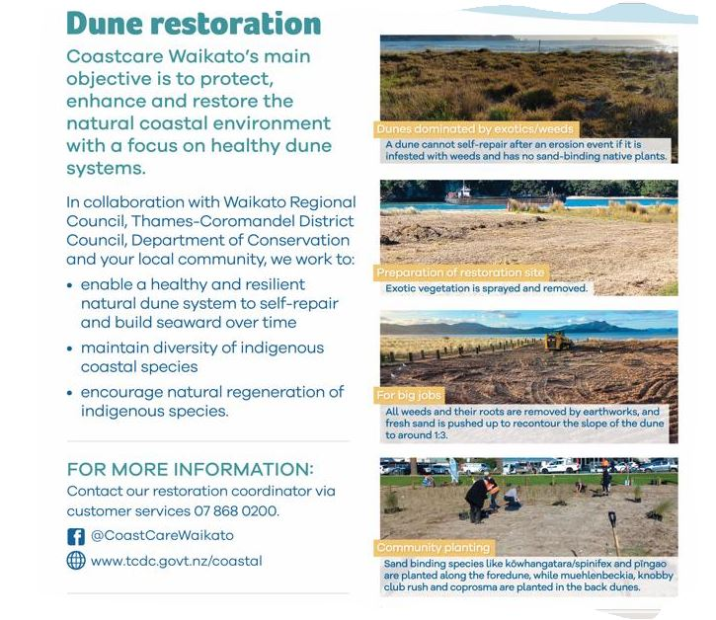
Refer to Powerpoint by Frank Geohegan presentation on Flooding impact during the cyclones of 2023.

Minutes are correct and accurate Document.
Moved by Steve Lloyd
Seconded by Paul Hopkins

Financial Report
Moved by Neira Giri
Seconded by Sue Mealing

Committee Nominations
Same as last year except for Yolanda Jamieson and including Neira Giri

