.

Agenda for our meeting on the 17th at The Vessel 4pm
- Minutes ( Cyndy)
- Correspondence (Cyndy)
- Financial Report ( Paulette)

Business arising from the Minutes
- Bollards at Flaxmill (Bruce)
- Groynes at Flaxmill ( Bruce)
- Disabled Access at the Purangi now part of the Submission
- Surveillance Cameras ( Kane)
- Roading Issues ( Cyndy)
- Hall Funding ( Cyndy and Paulette)

New Matters
- Purangi Upgrade ( Paul)
- Roading update (Cyndy)
- SUP ( Cyndy)

Mercury Bay Cycling Strategy
In 2019, our Council Council adopted a Cycling Strategy for Mercury Bay and funding was made available in the Long-Term Plan to implement this.
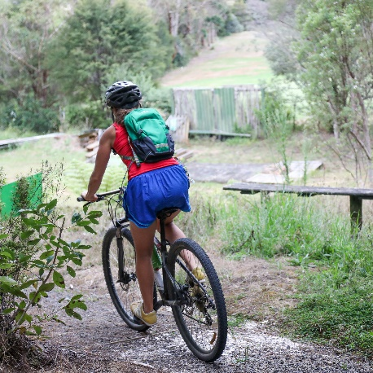
We’d like feedback from people in the district about any additional or amended cycling initiatives for Whitianga as well as the wider Mercury Bay area.
You can download maps for Whitianga and the Mercury Bay ward. Feel free to draw and write on them digitally or physically to show your suggestions and thoughts.
Please e-mail your feedback to George.Mathew@tcdc.govt.nz.
- Allan Henry to talk about new community based Project
- Freedom Camping ( Paulette)
- Tennis Courts (Paul)
- Stage 11 Upgrade for Village ( Paul)
- Rate Increase ( General Discussion)
As a result of these changes, the average District-wide rates increase for the 2022/23 financial year is proposed to be 8.3 per cent or $272, compared with 7.7 per cent or $253 forecast for the year in the LTP.
Next steps:
• 2-4 May - Hearings
• 24 May - Council deliberations on Submissions
• 28 June - Our Council adopts final Annual Plan, fees and charges and sets rates.

