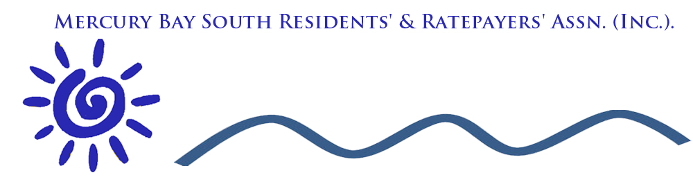

MBSRRA Committee Meeting

Agenda

Venue: Cooks Beach Resort
Date: 4/10/2018
Time: 1:00pm
Present: Welcome to special guest John Steele and new members Paulette Tainsh, Fletcher Handscomb, Kane Jones
Apologies:
Matters Arising : All matters covered in General Business with the exception of :
Maori Name for Cooks Stream

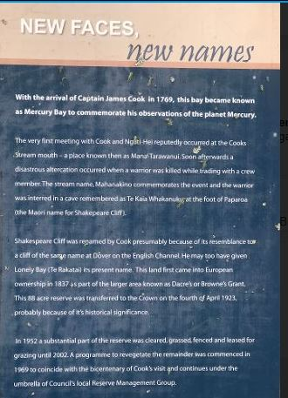

Outward Correspondence

July / August / September
- 28/07/2018 Letters to those owing Subs (9)
- 28/07/2018 Emails regarding the Minutes
- 29/07/2018 Email to Sue regarding Disabled Parking at Cooks Beach CBD and Ferry Landing
- 29/07/2018 Email Heather Bruce about disabled parking in CBD and Ferry Landing
- 5/08/2016 August Newsletter / Posted on Facebook
- 8/8/2 Updated Website on Boat Ramp issues / Posted on Cooks Beach
- 20/08/18 Email response to Bruce Chambers email regarding if the pontoon can be used as a Revenue gathering facility. Will bring up the issue at our next committee mtg
- 19/08/2018 Heather Bruce acknowledged receiving newsletter re Pontoon Issues
- 20/8/2018 Andrew Scobie requesting footpath extension from Mussel Bed to the Hall
- 23/08/2018 Acknowledged Fletcher, Kane and Paulette who are willing to join the Association. Added to Distribution List
- 9/9/2018 Letter to Paul Kelly regarding Tuia 250 Lack of inclusion of Cooks Beach / Flaxmill Bay
- 10/9/2018 Andrew Scobie Re. Erosion and Future Plans
- 10/9 2018 Alan Tiplady Re thanks for pathway from Mussel Bed to Hall
- 12/09/2018 Communication to Members, TCDC and John Steele regarding lack of consultation regarding Tuia 250
- 12/9 /2018 John Steele of speaking at next committee meeting re. about the impending celebrations of Cooks Visit
- 15/09/2018 Email to Heather Bruce and members of the South Ward with regards to signage (digital) for the stretch of road between the hall and Flaxmill Bay.
- 15/ 09/2018 Email to Heather Bruce about updates on pontoon pricing and solar lamp at the pontoon
- 19/09/ Paul Hopkins / Alan Henry regarding CBD walkway and parking
- Confirmation to John Steele about impending talk Re.Tuia 250

Inward Correspondence

July / August September
- 23/07/2018 Paulette Tainish would like to join committee
- 7/8/2018 Survey on Pontoon Collate and draw conclusions
- 8/8/2018 Heather Bruce / letter regarding disabled parking at Ferry landing and Cooks beach CBD.
- 20/8/2018 Heather Bruce will bring up MBSRRA conclusions will be addressed at the next Community mtg.
- Fletcher Handscomb workingfletch@gmail.com would like to join the Committee
- 23/08/2018 Kane Jones Willingness to join Committee
- 22/08/2018 received an in-depth, thoughtful submission from Bruce and Sally Chambers. Will forward onto Council and bring up at our next mtg Bruce_Chambers Submission to Thames Coromandel District Council.docx
- 23/08/2018 Email from Andrew Scobie / Updated Web Page regarding footbridge at Flaxmill Bay
- 15/09/2018 regarding speed restrictions sign for Cooks Beach / Purangi Rd needs to be replaced as it is missing
- 18/9/2018 Email from Paul Alan Henry regarding updates to CBD Cooks Beach
- 19/09/2018 Emails from Paul Hopkins / and Alan Henry regarding developments in Cooks Beach CBD
- 21/09/2018 Mel Bowen has resigned due to commitments with regard to charities
- 20/9/2008 Alison Henry: Project for Tuia 250
- 21/09/2018 Inclusion of Landscapers regarding the vacant ground alongside Richardsons and the Vessel
- 21/09/2018 Sue Costello Updated Garden area needs approval of MBRRA and Parks and Reserves area

Financial Report

General Business

- Tuia 250 : Information from John Steele and where for us
- Erosion Issues including trial groyne
- Fire Barometer regarding progress to Date
- Resignation from Dal Minogue. Mel Bowen and secondment of Fletcher Hanscom, Kane Jones and Paulette Tainesh
- Timed Parking Ferry Landing / Plans abandoned by TCDC
- Footbridge at Flaxmill / consultation and progress / Continuation of footpath to Shakespeare Point
https://mercurybaysouthratepayers.weebly.com/flaxmill-bay-foot-bridge.html

- Pontoon Report presented by Cyndy
- Cooks Beach CDB : Reserves Committee inspired pathway alongside Richardsons to Beach and Parking: Paul to report
- Local Body Elections Next year. Who do we want to represent us.

Next Meeting : 29th November

